Board of Management| Independent Director

Pic

https://drive.google.com/file/d/13kloLaB9jGo11qLhOyiU1QM9qKkEKGJR/view?usp=sharing |
Sarita Bahl is an alumnus of Tata Institute of Social Sciences and the Swedish Institute of Management Program. She superannuated in April 2024, as Director – Bayer Foundation India and Country Head, Bayer South Asia - Corporate Social Responsibility function.

An accomplished and versatile leader with over three decades of professional experience, Sarita has held multiple roles across diverse industries, public sector, trade associations, MNCs and Civil Society.

Her forte lies in co creating a holistic narrative to enhance the reputation of the organization by leveraging strategy, sustainability, societal development, internal & external communications, and stakeholder engagement opportunities.

Sarita is a certified Independent Board Director from Indian Institute of Corporate Affairs (IICA). As Chairperson of Bayer Foundation India, she oversaw the board governance and management. Sarita is a Non Executive Director with Etherwire.Ai and is also an advisory board member to ‘Pepperdine University,’ USA, ‘Synergy Technofin Pvt Ltd’, India, and ‘For Ethical AI (FEAi)’, India. She is a mentor at ‘Mentor My Board’ and the ‘Kerala Startup Mission.’ Sarita brings deep insights on the intersection of healthcare, nutrition, and sustainable social development (ESG & CSR).

As an Associate Certified Coach (ACC) from the International Coaching Federation (ICF) and Senior Practitioner (Mentoring) from the European Mentoring and Coaching Council (EMCC), Sarita specializes in career transition, inner engineering, and life issues. She blends her mentoring and coaching style to lead teams and projects across an array of topics.

Our Management Board of Advisors

Pic
Dr Rajani Tewari
Board & Advisory Leader | Governance • People • ESG • Transformation • Social Impact

About Rajani ,

Pic Download Link https://drive.google.com/file/d/1yIQ4vtGVnc0ifi9dxXS5OgzFS79AUE-9/view?usp=drive_link

Dr. Rajani Tewari is a Certified Independent Director, Board and C-suite People & Transformation leader with over two decades of experience across complex, high-growth and multi-stakeholder organisations. She brings a distinctive combination of business understanding, governance, human capital, ESG, ethics, institution building and social impact to the Boardroom.

Her career spans electric mobility, infrastructure, manufacturing, healthcare, education, technology, shared services and services, with experience across promoter-led, PE-backed and multinational environments. She has partnered closely with Boards, CEOs, promoters, investors and leadership teams through periods of scale, transformation, greenfield growth and organisational change.

Having led people strategies for organisations with 25,000+ employees across 12 geographies, Dr. Tewari understands both the strategic and operating dimensions of building sustainable institutions. Her experience encompasses Board advisory, organisational governance, leadership and succession, culture, talent, industrial relations, ethics, workforce risk, DEI, ESG-linked people practices and large-scale transformation.

In the sustainable mobility ecosystem, she has contributed to building organisational capability for a rapidly scaling, PE-backed electric mobility platform, working across frontline operations, workforce governance, industrial relations, compliance, diversity and ESG expectations. Her exposure to development-finance and institutional stakeholder ecosystems, including IFC, BII and GIZ, has further shaped her perspective on responsible growth and social sustainability.

For NGOs, foundations and social enterprises, Dr. Tewari brings particular value in helping organisations :
- Transition from passion-led initiatives to institution-led impact—strengthening governance, leadership
- Organisational capability
- Partnerships and systems without diluting the purpose for which they were created.

An author, speaker and social-impact chronicler, she has engaged with changemakers and organisations across education, livelihoods, inclusion, skilling and community development, giving her a wider lens on how business, people and purpose can converge to create sustainable impact.

………………………..

Pic
Shri. Soumya Kant Padhi
MD & Co-Founder Indorient Financial Services
About Soumya ,
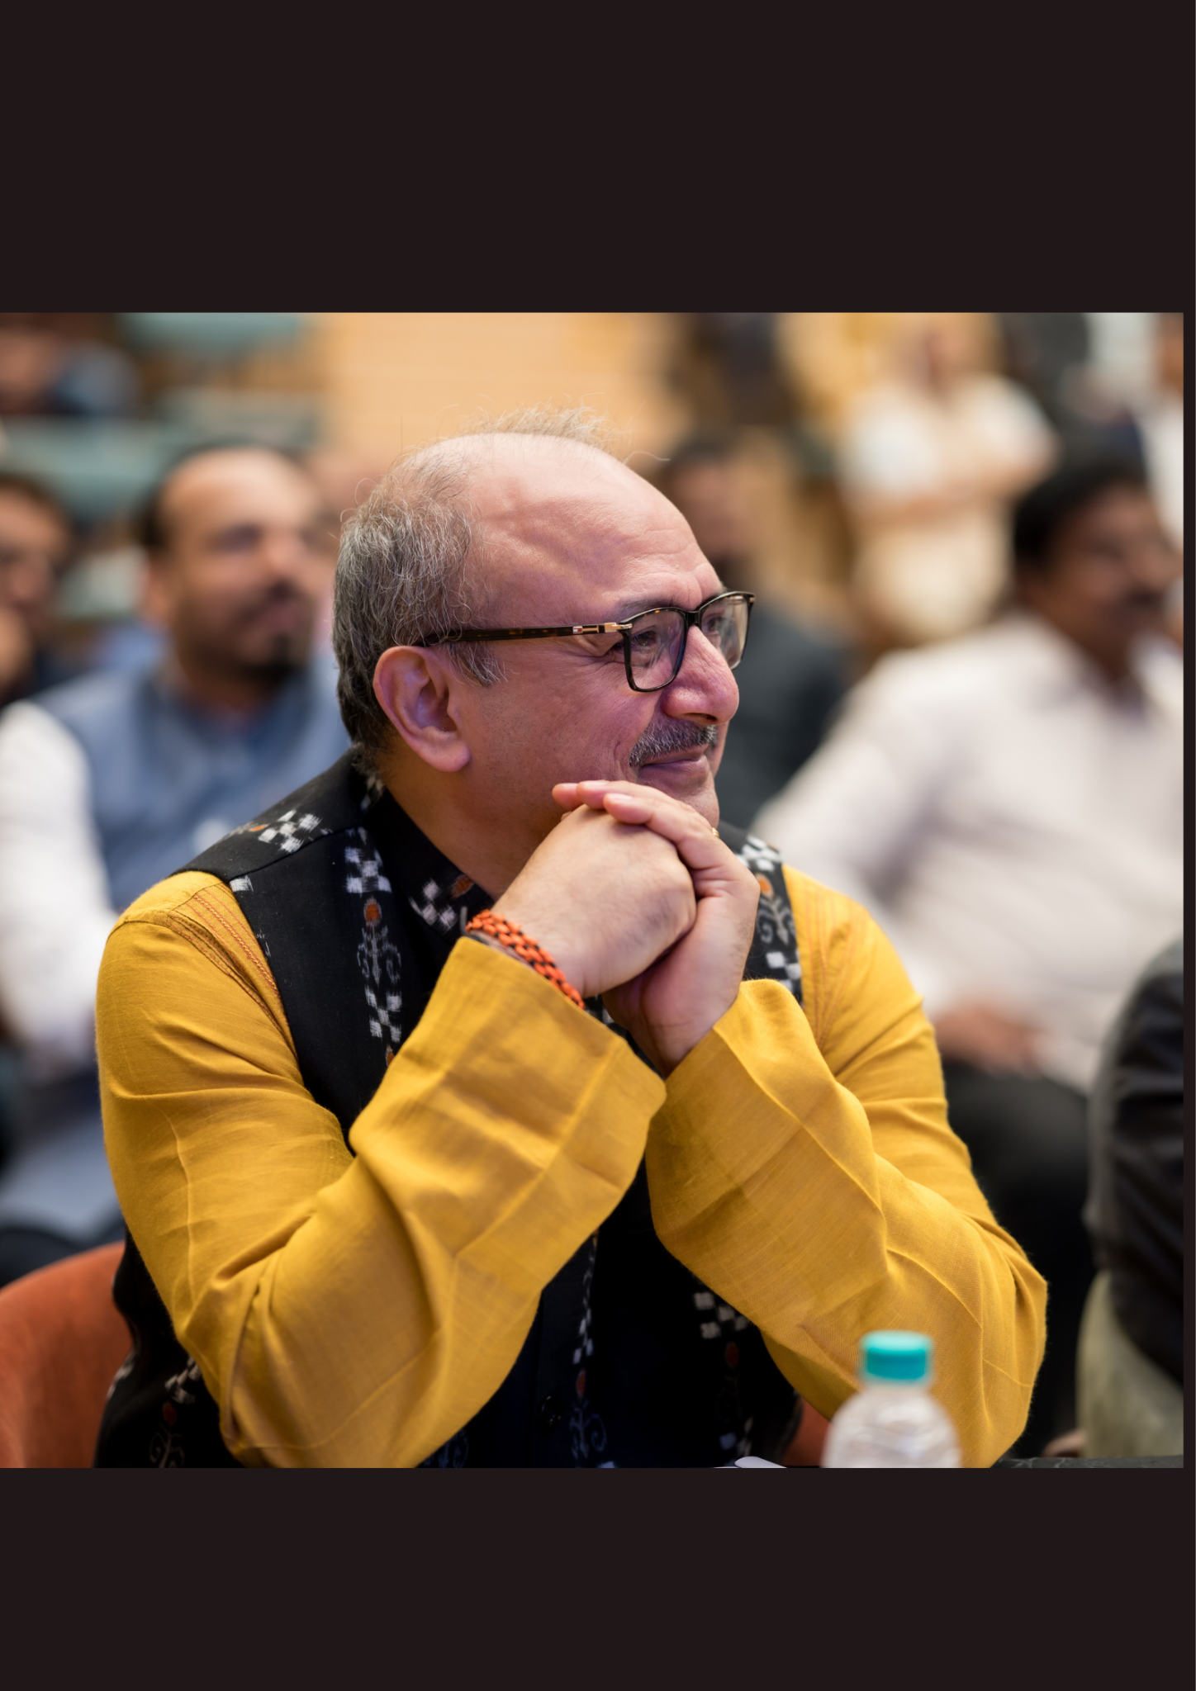
Soumya Kant Padhi is a seasoned financial services executive and capital markets expert with over two decades of experience driving business growth and market operations. As the Managing Director and Co-founder of Indorient Financial Services Limited, he spearheads the firm’s strategic vision and advisory initiatives.
His distinguished career includes pivotal leadership roles in establishing and scaling financial platforms. Notably, he served in senior management at the Global Board of Trade Ltd (GBOT) in Mauritius as a core team member managing startup projects and implementation for the international multi-asset derivative exchange. Prior to that, Padhi held key leadership positions at ICICI Bank as Chief Manager of Capital Markets and Country Head of Commodity Markets, overseeing national broker relationships and daily fund settlements. His foundational expertise was built at the National Stock Exchange of India Ltd (NSE), where he managed core market operations and provided operational support across regional frameworks.
Padhi holds an MBA from the Indian Institute of Management, Calcutta (IIMC), is an Associate Chartered Accountant (ACA) from the Institute of Chartered Accountants of India, and earned his Bachelor of Commerce from Utkal University. Beyond his leadership at Indorient, he is an active corporate director and board member for multiple ventures, including Intellivest Ventures & Accelerators and RCINDO Infotech.

Core Competencies
- Capital & Commodity Markets: Deep technical understanding of trading, settlement, and clearing operations across multi-asset derivative exchanges.
- Business Development & Strategy: Proven track record in establishing strategic roadmaps, regulatory policy formation, and driving growth for financial platforms.
- Operations & Risk Management: Extensive expertise in collateral management, daily credit limits, reconciliation, and navigating complex settlement activities.
- Corporate Governance: Seasoned board member providing strategic guidance for financial and technology ventures.

—------------

PIC
Dr V.Aditya Srinivas
Pic download here https://drive.google.com/file/d/1sWO53uoQbXItxH5a32OSyrZzIhAUWDg_/view?usp=drive_link

Dr V.Aditya Srinivas is currently working as Professor at Kohinoor
Management School. He has been actively involved in Corporate Relations
and Placement support. He takes subjects like Financial Derivatives,
Introduction to Financial Markets, Financial Insights.
Dr.V.Aditya Srinivas has worked as Chief Operating Officer and Chief
Economist at the Bombay Stock Exchange Brokers Forum. He has totally
20 years of corporate experience.
He has represented India at Harvard University USA, South Korea, Japan,
Maldives, Oman, Dubai, Hong Kong, Taiwan, Sweden, Indonesia, Turkey to
name a few countries..
He has taken more than 3000 sessions on Indian Economy and stock
market and trained more than 1.5 lac plus participants across India.
His qualifications are BBA Finance (Dist), MBA Finance (Gold Medal), Ph. D
(Economics) MDP (IIM Ahmedabad), CWM, D.Litt (USA), ISO 9000 Lead
Auditor.
Regularly comes on CNBC Bazaar for updates on monetary policy and
macro economic indicators.
He has also presented 23 research papers in National and
International conference and have published 35 Research papers.
Editor of In house magazine FORUM VIEWS which has been 8
consecutive years award at the ABCI function.
He runs his own NGO ADITYA SRNIVAS FOUNDATION to serve the needy
and poor which is at the core of his heart.

—---------------

Shri. Anand Chamaria
Co- Founder Equibeeipo

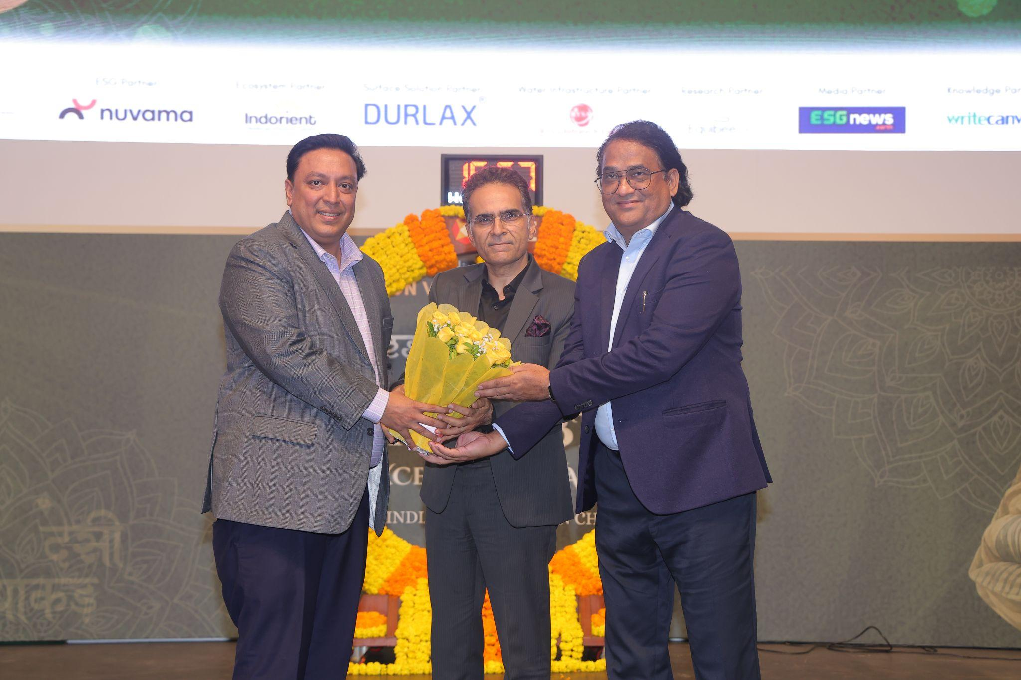

Executive Summary: Anand Chamaria
Anand Chamaria is an accomplished fintech leader, entrepreneur, and financial expert with over 23 years of extensive experience spanning supply chain finance, capital markets, and financial technology.

Professional Leadership & Ventures
- Founder & CEO of Invoicewale: Spearheads the development of digital-first platforms bridging the gap between finance and technology, helping empower SMEs with streamlined and efficient access to working capital.
- Co-founder of Guru Kripa Finance: Directs strategic initiatives and operations to deliver structured financial solutions and corporate advisory services.
- Cross-Sector Experience: Throughout his career, he has successfully led and managed initiatives across the fintech, telecom, and e-commerce sectors, driving corporate fundraising, market expansion, and strategic growth.

Core Expertise & Competencies
- Capital Markets & Fintech: Adept at creating digital transformation frameworks in supply chain finance and executing structured equity solutions.
- Strategic Growth & Financial Modeling: Specializes in capital structuring, financial forecasting, and driving scalable, long-term value creation for growing enterprises.
- Advisory & Ecosystem Engagement: Works closely with entrepreneurs and corporate leadership to optimize funding structures and unlock enterprise working capital.

Team
Founder & CEO

6225 working days 59k Hrs of Work exp & Millions of stories
https://drive.google.com/file/d/1-gPeV02jcdjruik_AMMMBRGbLiYfH1aC/view?usp=sharing
Founder with Passion & Purpose
EtherWire.AiTM & DesidhaakadTM
TedX Speaker
About Jyoti
A Brat turned business Sherpa!
With BSC Degree in hand but dipped in Life's skills, Jyoti
has an extensive range of wide experience, She is innovative and versatile thinker known for her startup expertise and successful business scaling in the Indian financial markets.
In the industry since 1998 , Jyoti is a seasoned sales specialist, excelling across diverse financial sectors for over two decades. She has played a pivotal role in launching and driving sales growth for new financial services and products, including mutual funds schemes, currency derivatives, and custodial services. Jyoti's strength lies in her ability to excel in competitive and underdeveloped markets, often exceeding sales targets. She has worked with exemplary leaders as she took on challenging roles across Reliance, Nippon AMC , Reuters, AIG, MCX, SBI Soc Gen , Edelweiss to name a few.

During her institutional sales tenure, Jyoti assisted asset management companies, hedge funds, venture capital funds, and foreign companies in establishing operations in India. Throughout her impressive career spanning 24+ years, she has raised over $5 billion in funds and serviced assets worth $100 billion in the Indian capital markets.

She attributes her success to active listening and client-first approach, consistently achieving exceptional results. Her sales and business development career parallels that of a growth hacker.

Passionate about creating opportunities for women in the financial sector, Jyoti is dedicated to empowering women across and with www.etherwire.ai , www.desidhaakad.com She provides invaluable resources, networking opportunities, and knowledge to help women carve their paths to success.

Known for her thought leadership, Jyoti has curated over 100 thought-provoking ideas and collaborated with leading fundraising platforms in India, including Invest India, Startupindia, IVCA, and mentoring several startups.

In her new avatar , she is founder of two firms - www.Etherwire.ai -a professional media platform , “Linkedin in times of Meta” & she is founder of for ethical ai community and has built unconventional Thinktank to bring ethics in Ai. her Community has received support from leading education institutes like SPIT , Bhavans College , IEEE , Startups like neuropixel , Devnagri etc

Awards & recognition

Jyoti is a firm believer in community building and is Amongst Top 3 “Women Power in Community Builder Award” at the “8th Annual Women Power Summit & Awards 2023” by Billennium Divas, a Global Community for WomenCurrently, as the India lead for 100 Women in Finance, She was acknowledged as a “Fire Brand in the Indian financial markets” by Eisner Amper (India).

Jyoti's personal achievements include being acknowledged as one of India's top 100 women leaders in finance in 2019 and as an "Influencing Women Leader" (BFSI Category) in 2019. She has also held positions as one of India's youngest independent directors on the board of a listed company and as the youngest-ever woman to head institutional sales in the mutual fund industry.

Read more…….

2012 Jyoti was integral part of Dr. Raguram Rajan’s team and worked on “The structure Quasi Sovereign and Sovereign issuance by Government backed institutions”. She was also part of the SEBI’s working group for “Committee on rationalization of investment routes and monitoring for foreign portfolio investments”.
She has in the past contributed to several white papers, one of them was tabled in G20 summit 2015, subjected as “Asymmetric Demography, Growth, and Global Financial Governance” on Indian Economy.

Mentoring startups, supporting old age homes, Travelling, reading & Arts of all forms inspires her in her free time. She is an avid reader of nonfiction & Indian mythology and has been writing her reflections on “in the world driven by Darwin theory of survival of the fittest where do genes of kindness come from”.

Jyoti's contributions extend to market advocacy, white papers, and participation in esteemed committees and working groups. She has been integral to promoting India's position on the global map of international financial centers, particularly as a driving force behind the GIFT City (IFSC) vision. Jyoti's expertise has also contributed to discussions on the BEPS( Base Erosion Profit Shifting) Report by OECD, focusing on the digital economy space.

As a private market investor since 2017 ,Jyoti finds sectors such as Social Impact , AI, Fintech, Data Science, Health tech & Alternative energy space very exciting. She advocates for technology that improves health, mental & financial well-being.

Jyoti holds a Science degree from Ajmer University, a PGDBM from SIMS, and has completed a "Board of Director" course from Copenhagen Business School. Additionally, she has received training in the Art of Negotiation from the Dale Carnegie Institute and in NLP.

Connect with Jyoti on LinkedIn:
linkedin.com/in/jyotirai
Founder www.etherwire.ai

Jacinta D'Souza
https://drive.google.com/file/d/1ddo9SpjtoZY98-fG0NQypcXW-LXwwT3m/view?usp=sharing
Chief of Operations & Production Controller, Etherwire
Jacinta D'Souza is the Chief of Operations and Production Controller at Etherwire, where she serves as the operational anchor driving the platform's media initiatives, narrative projects, and digital scaling. Combining rigorous administrative oversight with agile execution, Jacinta bridges the gap between creative vision and on-ground reality, ensuring every production milestone is met with precision and excellence.

Key Responsibilities & Impact
- End-to-End Production Control: Oversees the lifecycle of Etherwire's flagship media IPs. Collaborates closely with leadership, creators, and technical partners to translate strategic objectives into high-impact digital and broadcast deliverables.
Known for her meticulous attention to detail and calm execution under high-pressure environments, Jacinta ensures that Etherwire's commitment to impactful storytelling is matched by seamless behind-the-scenes infrastructure.

